# Exercise 2 – Odometry, Dead Reckoning and Error Predictions

Xu Fei, [feixu12@student.hh.se](mailto:feixu12@student.hh.se)

Qiu Yinan, [yinqiu12@student.hh.se](mailto:yinqiu12@student.hh.se)

**Abstract**

This exercise is focus on the effect of uncertainties on the measurement of the robot’s position. In this exercise, we have two kinds of robot, one is Khepera mini robot that use two-wheeled robot drive system, it’s as the same as the robot used in Wang’s paper, another one is Snowhite that use three-wheeled robot drive system. For the Khepera smini robot, the error (variance) of the encoder is set as 0.5/12 to calculate the forward direction and headings of the robot, and according to Wang’s paper, we use $\frac{\sin{θ_{n}/2}}{θ_{n}/2}$ as the compensation in this model, we use Jacobian matrix to get the uncertainty of the robot position. At last we get the plot of the path and the states of variables. In addition, we also try how the different parameters of the robot will affect the result, for example, we change the length of wheelbase from 53mm to 45mm, and the wheel diameter from 15.3mm to 14mm. For the Snowhite robot, there are there uncertainties for calculation: sample time, speed of the robot and the steering angel, we set the error of steering angle is 0.0001, error of speed is 0.0001 and error of sample time is 0.000001.

**Keywords:** uncertainty, vehicle position, Jacobian Matrix

1. **Introduction**

It’s very important to know how the system responses to different inputs for navigating an autonomous vehicle, in this exercise, we use the state variables $(x,y,q)$ to describe the position and the orientation of the robot, but for describing the position, we need to know the uncertainties of these three variables change with the same motion, it’s means how the wheels motion will affect these three variables. Therefore, we need to focuses on odometry what is the encoder values that are transformed into linear motions and the dead reckoning that is angles and speed that are sampled with a constant interval. The exercise also focus on how different parameters like wheel diameter and sample time will affect the uncertainty. In this exercise, we have two different kind robots, one is Khepera mini robot which is a two-wheel vehicle and Snowhite robot with a driving wheel in front of the vehicle, and we call it three-wheel vehicle. For the geometry, we assume that the path that the robot follow is a circle, then take the data coming from the encoders to do calculation, and compare to the circle to get the result.

In the fact situation, the optical decoder will have some error, so it will have uncertainty in describing the path of the vehicle, for decreasing the error, we use Jacobian Matrix as the measurement to do the position estimation.

1. **Theory and Method**
   1. **Model of the two-wheel driving system**

According to Wang’s paper (Location estimation and uncertainty analysis for mobile robots), we can get following model:

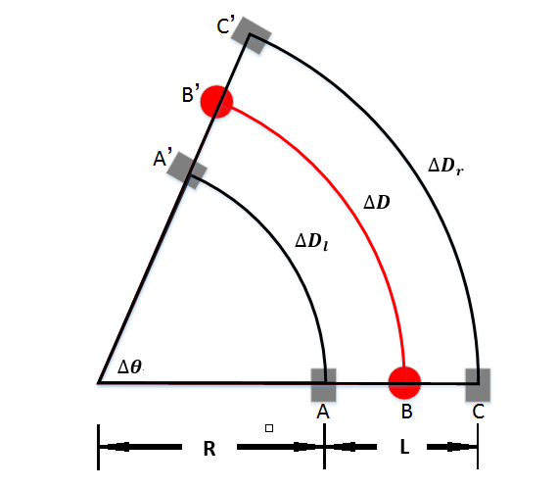

Figure 2.1 Geometry model of two-wheel driving system

In this model, the robot moves from B to B’. The length of the axis is $L=AC=A’C’$. $∆D$ is the distance that the vehicle travelled, $∆θ$ is the angle that the vehicle changed. $∆D_{l}$ and $∆D_{r}$ denote the covered distances of the right and left wheels respectively, then we can get the equation as following:



Figure 2.2 Illustration of relationship of position

$$∆D_{r}=(L+R)∆θ$$

$$∆D_{l}=R∆θ$$

Thus, we have:

$$∆D=(∆D_{r}+∆D_{l})/2$$

$$∆θ=(∆D_{r}-∆D_{l})/L$$

In two-dimensional space, we can use three parameters $(X,Y,θ)$ to describe the location of the robot, suppose we know that at time n-1, the robot is located at $O=(X_{n-1},Y_{n-1},θ_{n-1})$, from figure 2.2 we can see $θ_{n-1}=∠AOF$, $θ_{n}=∠ABP$. *BC* is parallel to *DE* and to *OP*, so

$$∠ABC=∠ADE=∠AOP=θ_{n}/2$$

Therefore, we have

$$∠POF=∠AOF-∠AOP={θ_{n-1}+θ}_{n}/2$$

For the general case of arbitrary path, the length of *OP* is unknown, so we use *OP’* to do the approximate, the length of $OP^{'}≈arc OP=∆D_{n}$ with this approximate we have:

$$X_{n}=X_{n-1}+∆X_{n}≈X_{n-1}+∆D_{n}\cos{({θ_{n-1}+θ}_{n}/2)}$$

$$Y_{n}=Y_{n-1}+∆Y_{n}≈Y_{n-1}+∆D_{n}\sin{({θ_{n-1}+θ}_{n}/2)}$$

$$θ_{n}=θ_{n-1}+∆θ_{n}$$

However, in the project, we assume the vehicle follow the path like circle, so we need to do compensation, the relationship between the length of *OP* and arc *OP* can be obtained as:

$$\frac{OP}{arc OP}=\frac{2(\frac{L}{2}+R)sin⁡(∆θ_{n}/2)}{(\frac{L}{2}+R)∆θ_{n}}=\frac{sin⁡(∆θ_{n}/2)}{∆θ_{n}/2}$$

$$OP=\frac{sin⁡(∆θ_{n}/2)}{∆θ_{n}/2}∆D_{n}$$

$$X_{n}=X_{n-1}+\frac{sin⁡(∆θ_{n}/2)}{∆θ_{n}/2}∆D_{n}\cos{({θ_{n-1}+∆θ}_{n}/2)}$$

$$Y_{n}=Y_{n-1}+\frac{sin⁡(∆θ_{n}/2)}{∆θ_{n}/2}∆D_{n}\sin{({θ_{n-1}+∆θ}_{n}/2)}$$

$$θ_{n}=θ_{n-1}+∆θ_{n}$$

From the figure 2.2 we can know that, $∠ABC=θ_{n}/2$, when the sample time is becoming faster and faster, the $θ_{n}/2$ will become smaller and smaller, so the result that $\frac{sin⁡(∆θ_{n}/2)}{∆θ_{n}/2}$ will very close to 1, that why the length of $arc OP$ is almost the same as length of straight line $OP$. But here, we need to do some compensation also because the error will arise all the time, we will show it later.

* 1. **Model of the three-wheel driving system**

The second model in this exercise is three-wheel robot, it’s called Snowhite, and we can see the schematic model in figure 2.3, only the heading wheel will control the direction of the robot, and the data include the rotation of both the steering wheel and driving wheel ,and also the position for each time (The initial sample time is 50ms).

For the Snowhite, the wheelbase is L

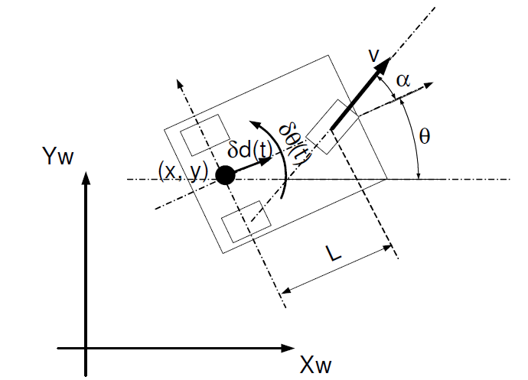

Figure 2.3 Schematic model of the three-wheel robot

* 1. **Auto-correlation**

1. **Results and answers**
   1. **Transform Longitude and Latitude Data from Angles to Meters**

F

$$dd.dddddd=dd+\frac{mm.mmmm}{60}=\left[\frac{ddmm.mmmm}{100}\right]+\frac{ddmm.mmmm-\left[\frac{ddmm.mmmm}{100}\right]×100}{60}$$

The code in matlab can be:

LongDeg = floor(Longitude/100) + (Longitude - floor(Longitude/100)*100)/60;

LatDeg = floor(Latitude/100) + (Latitude - floor(Latitude/100)*100)/60;

Second step: Then process the degrees into meters(use the conversion tables given in the end of the compendium[2]), assume height zero and latitude of 56 degrees. where a = 6378137 m, b = 6356752.3142 m, h – height.The code can be:

X = F_lon * LongDeg;

Y = F_lat * LatDeg;

Figure 3.1 shows the X,Y position in the coordinate system.

Figure 3.1 X,Y position

* 1. **Estimate the Mean and Variance of the Position (X and Y)**

1. Error

First, calculate the mean value of x and y(the position in the coordinate), and use the original x,y data minus the mean value of x,y to get the error. Then plot the error in histogram form. Use histfit() function to draw the normal Gaussian distribution(red curve in figure 3.2) and compare with error histogram.

Figure 3.2 shows the result.

Figure 3.2 Error histogram of x and y

As shown in the figure 3.2, blue column line represent the error of x,y, we can see it clearly that is almost fit the shape of red curve which represent the normal Guassian distribution. Therefore, the error of x,y follows the Guassian distribution. According to the calculation, we found that the maxim error in x is 5.89001, maxim error in y is 7.33283.

1. Co-variance Matrix

Calculate the co-variance matrix of the errors in the x and y position data, in Matlab simply write cov([X Y])if the errors stored in x and y as [N x 1] vectors.

Use the function ‘'plot_uncertainty([0 0]’, cov([X Y]), 1, 2)’ which then plots the co-variance matrix centred around (0, 0). Figure 3.3 shows the result.

Figure 3.3 Error and co-variance matrix

* 1. **Plot with Respect to time, the Errors and the Auto-correlation in X and Y Separately.**

1. Plot of X and Y

Here, we plot with respect to time, the errors in x and y separately, use Matlab’s function of creating subplots.In figure 3.4, it plot the errors of x and y, the errors of x and y are antithetical, for example at 9000, the error of x is near to 0.5 above the mean value, but the error of y is near to -0.5 below the mean value.

Figure 3.4 errors of x,y position

1. Comparison of Auto-correlation

Here, we plot the auto-correlation of the errors in x and y respectively. Call the function ‘xcorr()’. The result is shown in figure 3.5, the blue line present the auto-correlation of random signal, the red line present the auto-correlation of error in x, the green line present the auto-correlation of error in y.

Figure 3.5 Auto-correlation of x and y

From the result, we can see that the auto-correlation of errors in x,y present are much more closed to itself than the random signal. The GPS error is correlated, and it will arrive the peak around about 0.97×104 in abscissa. Compare to the random signal, the GPS errors has more effects when sometime it arrive its peak, but the other time, GPS errors are much more closed to itself than the random signal.It means that the GPS errors will repeat it all the time and it has a time shift for a certain time when it arrive its peak.

* 1. **Mobile GPS Receiver**

1. Plot the Data of Mobile GPS Receiver

Plot the position data (x and y) in the same plot (the path taken by the car) by using the data set ‘gps_ex1_morningdrive2012.txt’, which is collected during a drive on the eastern side of Halmstad. Use the same method as the static GPS receiver to transform the data into meters form.Figure 3.6 shows the path of the car. Figure 3.7 shows that path on the map of a part of Halmstad city.

Figure 3.6 Mobile GPS's path

Figure 3.7 Path of driving in east part of Halmstad city

Here, we should resize the map of the part of Halmstad, because we should to make it fit to the plot figure in Matlab, then use plot function to get the trace of the car on the map.

1. Calculate the Speed and Headings of the Vehicle

From the paper we know that the sample rate of GPS receiver is 1Hz, Distance between two points (figure below) can be found using the following formula(λ is longitute, ψ is latitude):

$$Distance=\sqrt{{{(F}_{Lat}(φ_{1}-φ_{2}))}^{2}+{{(F}_{Lon}(λ_{1}-λ_{2}))}^{2}}$$

$$V=\sqrt{V_{x}^{2}+V_{y}^{2}}=\frac{Disatance}{1}$$

Where Vx mean the speed of direction x and Vy mean the speed of direction y, we calculate the speed in separate direction at first then combine them together.

For calculating the heading, we use the following formula:

$$if λ_{1}=λ_{2} then Heading={360}^{°} or {180}^{°}$$

$$if λ_{1}<λ_{2} then Heading={90}^{°}-\tan^{-1}\left(\frac{F_{Lat}(φ_{2}-φ_{1})}{F_{Lon}(λ_{2}-λ_{1})}\right)$$

$$if λ_{1}<λ_{2} then Heading={270}^{°}-\tan^{-1}\left(\frac{F_{Lat}(φ_{2}-φ_{1})}{F_{Lon}(λ_{2}-λ_{1})}\right)$$

We use the function 'atan2(Dy,Dx)' in matlab to calculate the heading of the vehicle. Figure 3.8 shows the velocity and heading of the vehicle respect to time.

Figure 3.8 speed and heading of the vehicle

According to the figure, because the speed is calculated by the difference between the two points, so the subtraction calculation will eliminate part of the errors, but the position data is obtained directly from the data, so the speed will be more accurate than the position estimation.

We must calculate the error of the heading separately, that means we should divide the whole path into several segments according to every period of the vehicle. Because when the vehicle is in a high-speed and low-speed, the variance vary greatly.For example, when the vehicle driving on Laholmsvägen is approximately 240 to 310, the variance is 1.7632, But when driving on Kyrka with very low speed, the variance is 9.1601e+03. The comparison of the errors is shown in figure 3.9.

Figure3.9 Error of Heading drive during Laholmsvägen

Because there is errors in static measurement, it's like a uncertain point vibrating, thus when calculating the headings, even every small error can make two adjacent value different and cause large difference in headings. While driving at a high speed, it's like a super large scale compare with the GPS error, thus the error comes less important. The heading will not effect largely by GPS error.

1. **Conclusions and further improvements**

First, this exercise let us understand how the GPS works, learn how to analyze the data that obtain from the GPS receiver and the analytical of errors. In analyze the data, we transform the e original GPS data to the meter form that can be calculated. In analyze error, we learn the relationship between the covariance and the errors in position, and understand how the auto-correlation influence the estimation of the position. Then, in the second part, we use the data obtained by the mobile GPS receiver to do some basic functions of GPS, just like how to calculate of the vehicle speed, vehicle heading and so on.

Further improvements should be made for step forward, for example, more material should be referenced and detail of theory and method should be provide in section 2 and it would be more practical if can access to the data receive section of GPS, in other word, get data on our own and thus will be more data type to analysis.

**Reference**

[1]

[2]

[3]

[4]

[5]